The Courtyard

Welcome Pack
&
Information Guide

Useful Information

Students Union – Spar Shop
The University of Hull Campus Spar Shop is located in the Students Union Building. It stocks a range of necessities including snacks, cigarettes and toiletries.
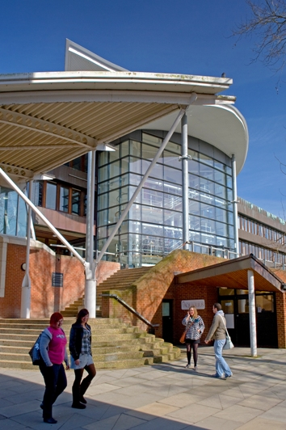
Opening times:
Monday – Friday 8:00am – 6.00pm
Saturday 8.00am – 8:00pm
Sunday 8:00am – 8:00pm

University of Hull, Student Union
The University of Hull Student Union is located next to Staff House on the campus. Entry is free to all residential conference delegates.
Facilities include two bar areas, both serving alcoholic and non-alcoholic beverages, plasma TVs, pool tables and games machines.
A menu of hot and cold food is served as follows:
Monday – Friday 8 am - 4pm
Saturday and Sunday 8 am - 4pm
Timings are subject to change without prior notice.

Cash Point
There are two cash machines located outside of the Students Union Building. There is no charge for making standard cash withdrawals. There is an emergency call number on the side of the cash machine should any problems occur.

Campus Food and Beverages
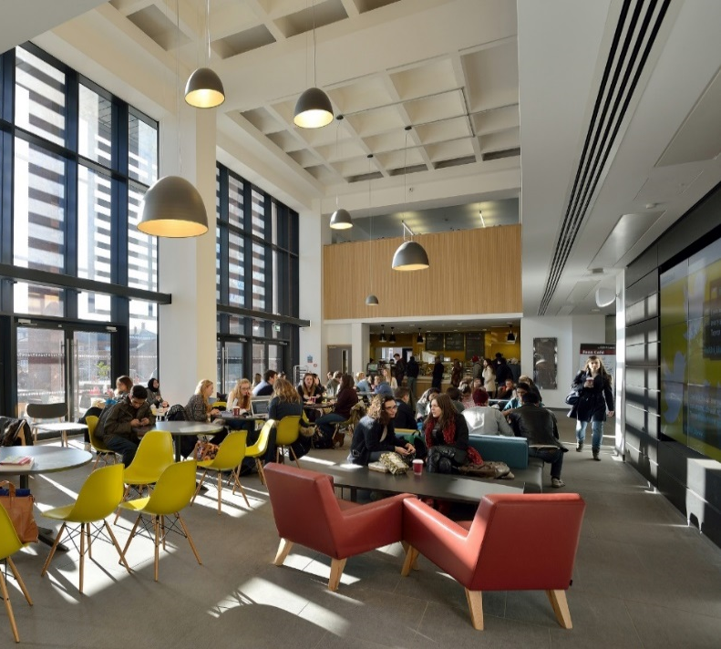
There are many outlets located around the University of Hull campus selling beverages and snacks as follows:
Café | Opening Times:
The Art’s Cafe | Mon/Fri: 8am - 8pm  Saturday: Closed  Sunday: Closed
Foss Café | Mon/Fri: 8.30am -2.30pm  Weekends: Closed
Derwent Café | Mon/Thurs: 8.30am -5pm  Fridays: 8.30am -4.30pm  Weekends: Closed
Library Café | Mon/Fri: 7.30am -9.30pm  Weekends: 9am - 6pm
Zucchini’s | Mon/Fri: 8.30am - 4.30pm  Weekends: Closed
Street Eats | Mon/Fri: 8.30am - 2pm  Weekends: 8.30am - 2pm
Sanctuary Bar | Mon/Fri: 9am – 11pm (food served until 8pm)  Weekends: Closed

Sports Facilities
The University of Hull is investing heavily in our sports facilities over the coming years to establish ourselves as a market leader within the Higher Education sector and local area.
For September 2017/18 we have a newly furbished fitness suite with state of the art resistance and cardiovascular equipment to support your individual goals. Alongside a fully equipped fitness suite we have a varied group exercise class timetable ranging from high energy activities to more holistic style yoga and Pilates classes to compliment your training.
As a sports centre we also have the capacity to host variety of activities such as badminton and squash as well as a host of turn up and play sessions ran by our Sports Development team.
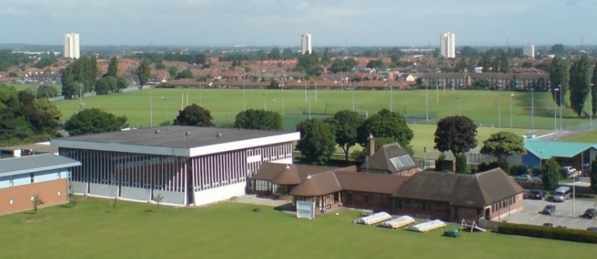
Opening Hours:
Monday – Thursday Health & Fitness
7.00am – 10.00pm

Saturday & Sunday Health & Fitness –
9.00am – 7.00pm

For more information on facilities, class timetables, activity programmes, membership and one day access contact the University of Hull Sports and Fitness Centre reception on (01482) 466234

Campus Parking and Travel Information
If a parking permit has not been pre-arranged by your Conference Organiser, please contact them for further information.
Parking is strictly subject to availability. As part of our ongoing commitment to the environment, we encourage delegates to use public transport or car share.

Public Transport

Local Bus Service

Buses are available from Paragon Interchange to the Hull campus on average every 10 minutes during the day. It will cost approximately £2.00 for a single fare and £3.50 for a day return (price correct as at January 2017).

- Bus Numbers to City Centre: 103, 105 & 115
- Bus Line: Tel: (01482) 59 29 29
- www.eyms.co.uk
- www.twitter.com/EYBuses

Hull Paragon Train station is a fifteen-minute taxi ride from The Courtyard.

Local Taxi Companies

Taxi firm | Telephone number
Hull Cars | 01482 828 282
65 Cars | 01482 656 565  01482 500 602
70 Cars | 01482 446 622  01482 707 070
Eight Five Cars | 01482 858 585
Five Seven Cars | 01482 575 757  01482 447 777
Six O Cars | 01482 606 060  01482 440 440
Three Five Cars | 01482 353 535

Other Useful Information

Banks

The nearest bank is Natwest Bank located: 4 Cottingham Road, Hull
Tel: 0345 788 8444

Post Office

The nearest post office is Falmouth Street Post Office located: 105 Cottingham Road, Hull
Tel: (01482) 343105

Personal property
Please note you are responsible for your own property during your stay at The Courtyard. Whilst we take every care, the University cannot accept responsibility for any loss or damage to personal property.

Emergencies and First Aid

In the event of an emergency or if you are feeling unwell please call Reception on 2080 on an internal phone between 8am - 11pm, or if out of hours please contact Security Services by dialling 6868 from an internal phone or from an external phone on (01482) 466868 at any time throughout your stay. If you’ve had to call an ambulance, please contact Reception or Security at The Courtyard.

Smoking Policy

The University has a no smoking policy; however, there are designated smoking areas across the campus clearly marked approximately 5 metres from the main building entrances.

Laundry Services

A launderette is available for use in The Courtyard and access is 24 hours. If you would like to use the service please register online at www.circuit.co.uk and download the App on IOS or Android phones. Alternatively if you have a different phone you can collect a card from The Courtyard Reception.

- Laundry Costs: Wash - £3.10 Tumble Dry - £1.30
Where to Eat Near Campus?
Restaurant | Type of Food | Where is it? | Telephone Number? | Address: | Opening Hours | Price Range | Website
Pave | Café Bar | 1.8 miles (35 min walk) from The Courtyard | 01482 333181 | 16-20 Princes Avenue  Hull  HU3QA | Mon-Thu: 11am - 8pm  Fri-Sat: 11am - 7pm  Sun: 11am - 5pm | £6.45 - £16.95 | www.pavebar.co.uk
Lucca Bar & Kitchen | Pizza & Pasta | 1.6 miles (31 min walk) from The Courtyard | 01482 470088 | 84 Princes Avenue  Hull  HU5 3QJ | Mon-Sun: 12pm - 9.30pm | £8.25 - £26.95 | www.luccahull.co.uk
The Fish & Chip Kitchen | Fish & Chips | 1.6 miles (31 min walk) from The Courtyard | 01482 440400 | 78 Princes Avenue  Hull  HU5 3QJ | Mon-Sun: 12pm - 11pm | £4.00 - £10.50 | www.thefishandchipkitchen.co.uk
Garbutts | Gastropub | 1.7 miles (33 min walk) from The Courtyard | 01482 343490 | 50/54 Princes Avenue  Hull  HU5 3QG | Mon-Thu: 11.30am - 8.30pm  Fri-Sun: 11.30am - 7pm | £7.85 - £14.95 | www.garbuttsbar.co.uk
Aunt Bibby’s Smokehouse | American | 1.7 miles (33 min walk) from The Courtyard | 01482 447733 | 12a Princes Avenue  Hull  HU5 3QA | Mon-Wed: 5pm - 12am  Thu-Sun: 12pm - 12am | £6.50 - £14.00 | www.auntbibbys.com
Roots Bar | Caribbean | 0.8 miles (15 min walk) from The Courtyard | 01482 440000 | 206 Newland Avenue  Hull  HU5 2ND | Mon-Sun: 12pm - 2am | £7.95 - £11.00 | www.rootsbarhull.co.uk
Bengal Lounge | Indian | 1.8 miles (35 min walk) from The Courtyard | 01482 473945 | 31-33 Princes Avenue  Hull  HU5 3RZ | Sun-Thu: 5.30pm - 11pm  Fri-Sat: 5.30pm - 12am | £5.00 - £8.50 | www.bengalloungeindian.co.uk
Ruby Lounge | Mexican | 0.8 miles (15 min walk) from The Courtyard | 01482 442233 | 179 Newland Avenue  Hull  HU5 2EN | Closed Mon  Tue-Thu: 12pm - late  Fri-Sat: 11am - late  Sun: 12pm - late | £7.50 - £12.95 | www.rubyloungehull.co.uk
Frequently Asked Questions
Do you have any rooms with a bath fitted?
Unfortunately, all of our rooms are single bed with an en-suite shower. None of our rooms have baths.

Can I charge items to my bedroom?
Any additional services that incur a charge are unable to be charged to a room. These must be settled on a cash basis; however, some specific services can be paid via credit/debit card.

Help, I am locked out of my room.
Please report the problem to the helpdesk team at The Courtyard Reception, they will then call security to give you access to your room.

How much is a lost or broken key card?

The cost to replace your key card if it has been lost or broken is £5, please enquire at The Courtyard Reception.

Is there an Iron/Ironing-board for use?

You will find an Iron and Ironing-board in the cleaning cupboard located in the Kitchen.

Where can I buy an international plug?

You will be able to purchase an international plug from the Student Union Spar shop on campus or alternatively from Tesco at St Stephens’s in Hull City Centre.

Where is the nearest post box?
The nearest post box is located outside the entrance of the Student Union building.

Is there any social space to relax and unwind?
As well as the facilities at the Student Union and Catering elements across the University Campus, within The Courtyard there is a Communal Lounge near to reception.

If you have any additional questions which have not been covered, please feel free to ask a member of staff or contact one of the events team. We hope you have an enjoyable stay at The Courtyard.

Please note all details are correct at time of going to print. We do not accept any liability for any changes in times or information post printing.

